Fracking Operations in Llano River Watershed

Overview Map Showing western Kimble County, eastern Sutton County and Northern Edwards County. Note Stewart Ranch and Ray Lake Quads along Sutton and Edwards County line.

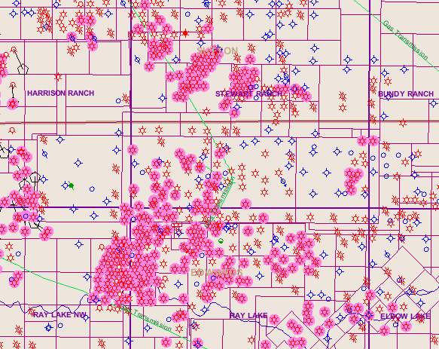
Natural Gas wells using fracking techniques shown as Red Circle highlighted in pink. Red Circles without highlight are natural gas wells. Blue Circles are dry holes. (Source: Texas Railroad Commission Public GIS Map Viewer, accessed May 8, 2011.)

