­­

Guadalupe Bass and Fish Communities in the South Llano River

Texas tech graduate students assisting state to assess



Due to the springs that supply its flow, the South Llano River has never ceased flow in recorded history. Currently, it is considered relatively pristine with good water quality and habitats that support a diversity of fish communities, including a naturally occurring population of the Texas State Fish, Guadalupe bass.

However, growing human populations and natural disturbances, such as overgrowth of juniper species or wildfires like the Oasis Wildfire in April 2011, have the potential to decrease the water quality and quantity as well as degrade natural habitats of the river. Conservation efforts dedicated to restoring habitat for Guadalupe bass have been underway since 2010, however detailed habitat data for this and other fish species is lacking.

Texas Tech University Graduate students, Brandon Cheek and Jillian Groeschel, hope to collect data to aid Texas Parks and Wildlife in the development and assessment of current and future restoration activities. Brandon’s research focuses on assessing the habitat associations of fish communities in the South Llano River, while Jillian is focusing solely on habitat associations and patterns of Guadalupe bass.

Data collection will involve snorkel surveys, catching fish in seine nets, and tracking juvenile Guadalupe bass by tagging them with Passive Integrative Transponder (PIT) tags.

C

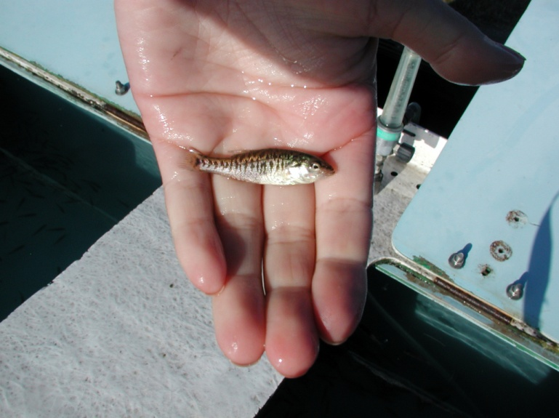

*Jillian Groeschel will be tagging 500 juvenile Guadalupe bass and releasing them in the South Llano River to track and determine their habitat associations.*

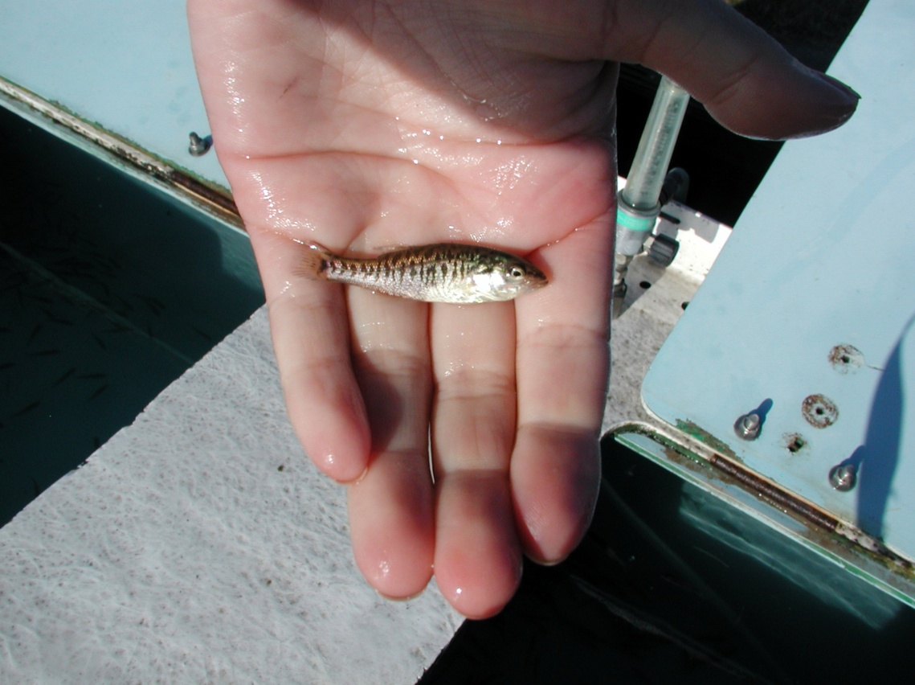

The South Llano River Watershed Alliance, lead is a proactive group of landowners and stakeholders interested in protecting the rivers and streams of the Llano River Watershed.

“We really appreciate the willingness of landowners to allow us to access their land so we can sample different areas of the river,” said Jillian. The two will be diving into their research this summer and will be collecting data for the next year.

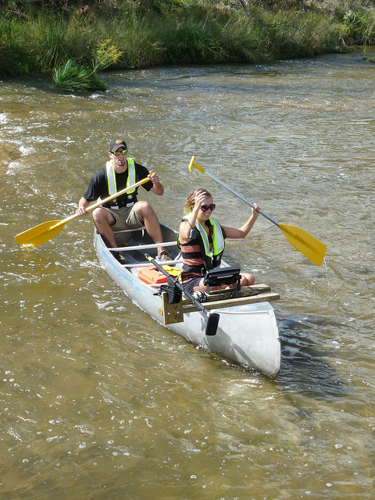

Texas Tech University Graduate students, Brandon Cheek and Jillian Groeschel used sonar to map out the bottom substrate of the South Llano River. This map will be used to choose sample locations and assess habitats of Guadalupe bass and other fish.